R PROGRAMMING

EXPERIMENT-1 ADDITION:
AIM:
To prove the program for addition using R-tool.
PROGRAM:
num1 <- as.numeric(readline(prompt = "Enter the first number: "))
num2 <- as.numeric(readline(prompt = "Enter the second number: "))
sum_result <- num1 + num2
print(sum_result)
OUTPUT:
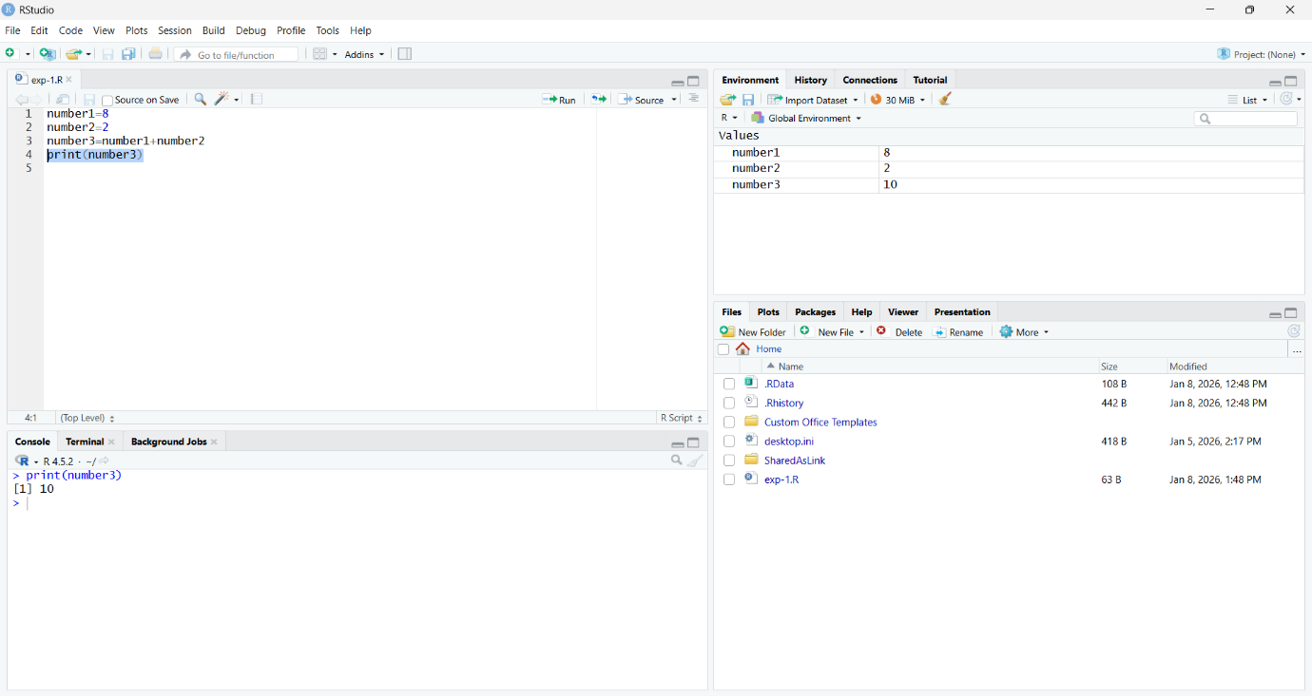
RESULT:
Thus the basic program addition is executed successfully.

EXPERIMENT-2 SUBTRACTION:
AIM:
To prove the program for subtraction using R-tool.
PROGRAM:
num1 <- as.numeric(readline(prompt = "Enter the first number: "))
num2 <- as.numeric(readline(prompt = "Enter the second number: "))
difference <- num1 - num2
print(difference)
OUTPUT:
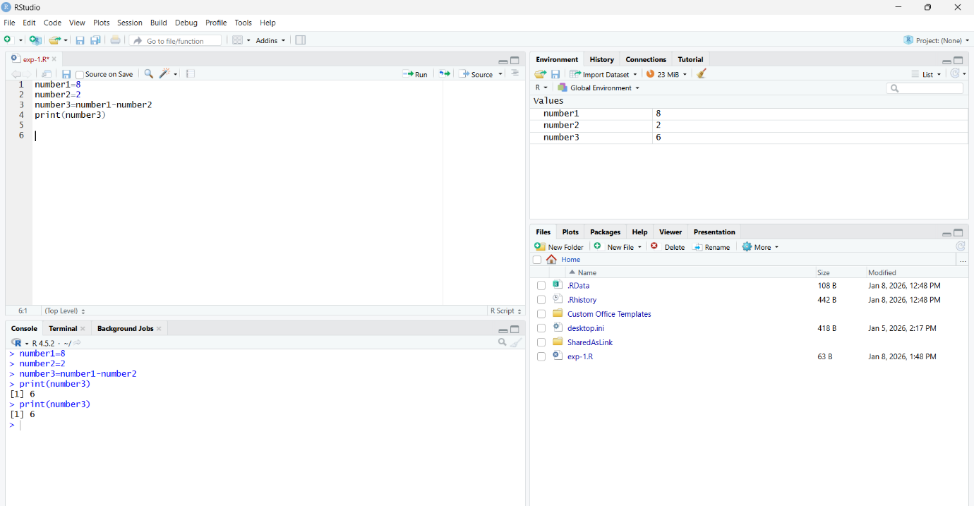
RESULT:
Thus, the basic program subtraction is executed successfully.

EXPERIMENT-3 MULTIPLICATION:
AIM:
To prove the program for multiplication using R-tool.
PROGRAM:
num1 <- as.numeric(readline(prompt = "Enter the first number: "))
num2 <- as.numeric(readline(prompt = "Enter the second number: "))
product <- num1 * num2
print(product)
OUTPUT:
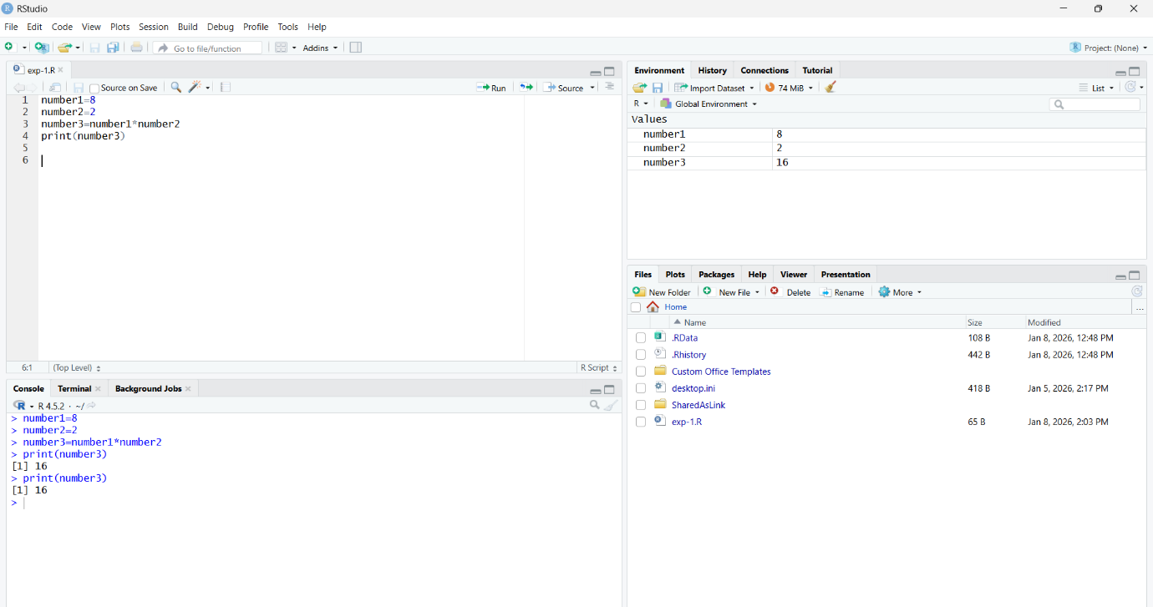
RESULT:
Thus, the basic program multiplication is executed successfully.

EXPERIMENT-4 DIVISION:
AIM:
To prove the program for division using R-tool.
PROGRAM:
num1 <- as.numeric(readline(prompt = "Enter the first number: "))
num2 <- as.numeric(readline(prompt = "Enter the second number: "))
if (num2 == 0) {
stop("Division by zero is not allowed.")
}
quotient <- num1 / num2
print(quotient)
OUTPUT:
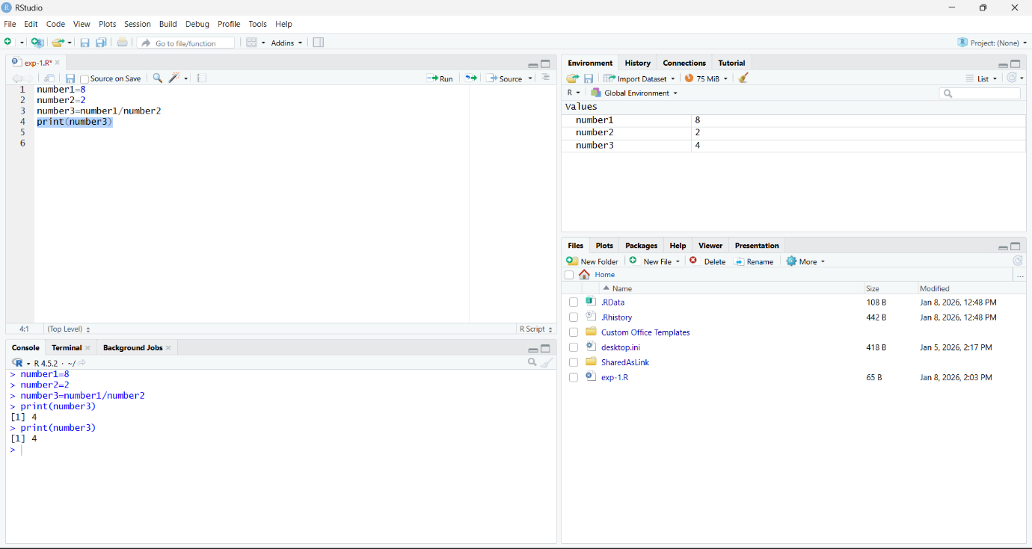

RESULT:
Thus, the basic program division was executed successfully.

EXPERIMENT-5 ODD OR EVEN:
AIM:
To write the program for odd or even using R-tool.
PROGRAM:
num <- as.integer(readline(prompt = "Enter an integer: "))
if (num %% 2 == 0) {
print("Number is even")
} else {
print("Number is odd")
}
OUTPUT:
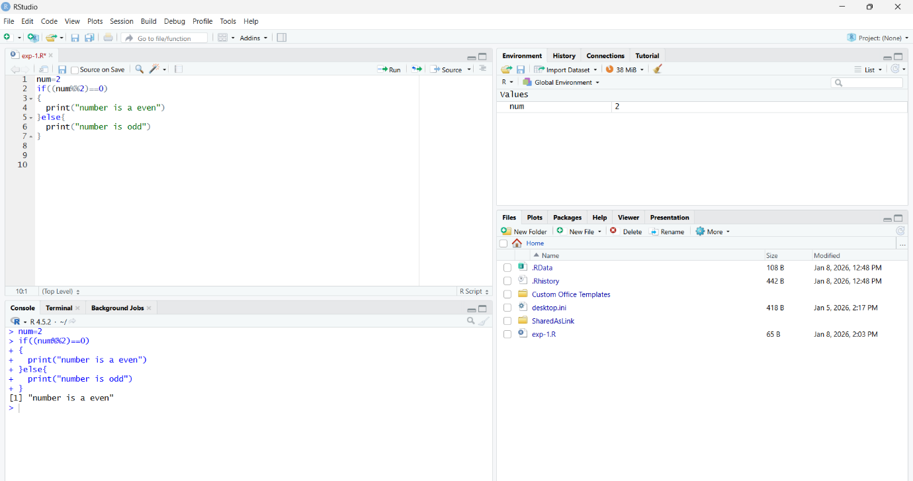
RESULT:
Thus, the basic program odd or even was executed successfully.

EXPERIMENT-6 MEAN,MEDIAN,MODE:
AIM:
To write the program for mean,median,mode.
PROGRAM:
names <- c("siri", "mahi", "chiru")
age <- c(23, 24, 25)
marks <- c(88, 78, 25)
df <- data.frame(names, age, marks)

# Mean and median of age
mean(df$age)
median(df$age)

# Statistical mode (returns NA when every value occurs once)
get_mode <- function(x) {
tab <- table(x)
if (max(tab) == 1) return(NA)
as.numeric(names(tab)[tab == max(tab)][1])
}
get_mode(df$age)
write.csv(df, "datafr.csv", row.names = FALSE)
OUTPUT:
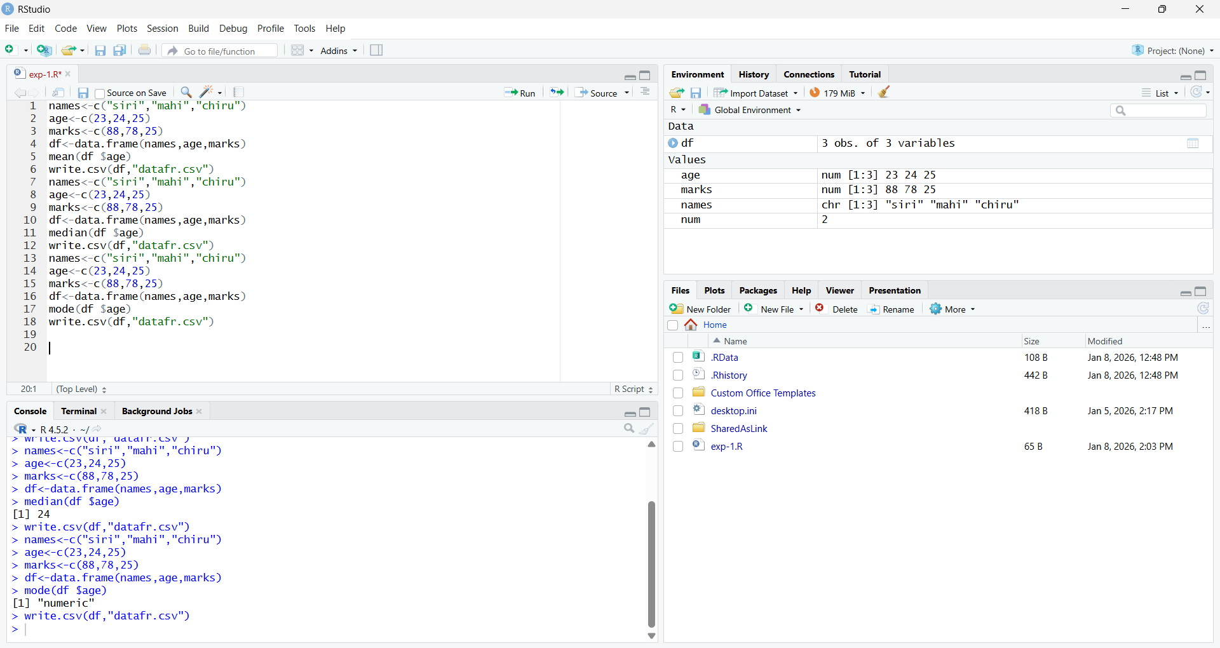
RESULT:
Thus the central tendency and measure of dispersion is executed successfully.

EXPERIMENT-7 SUMMARY:
AIM:
To write the program for summary using R-tool.
PROGRAM:
names <- c("siri", "mahi", "chiru")
age <- c(23, 24, 25)
marks <- c(88, 78, 25)
df <- data.frame(names, age, marks)
summary(df$age)
write.csv(df, "datafr.csv", row.names = FALSE)
OUTPUT:
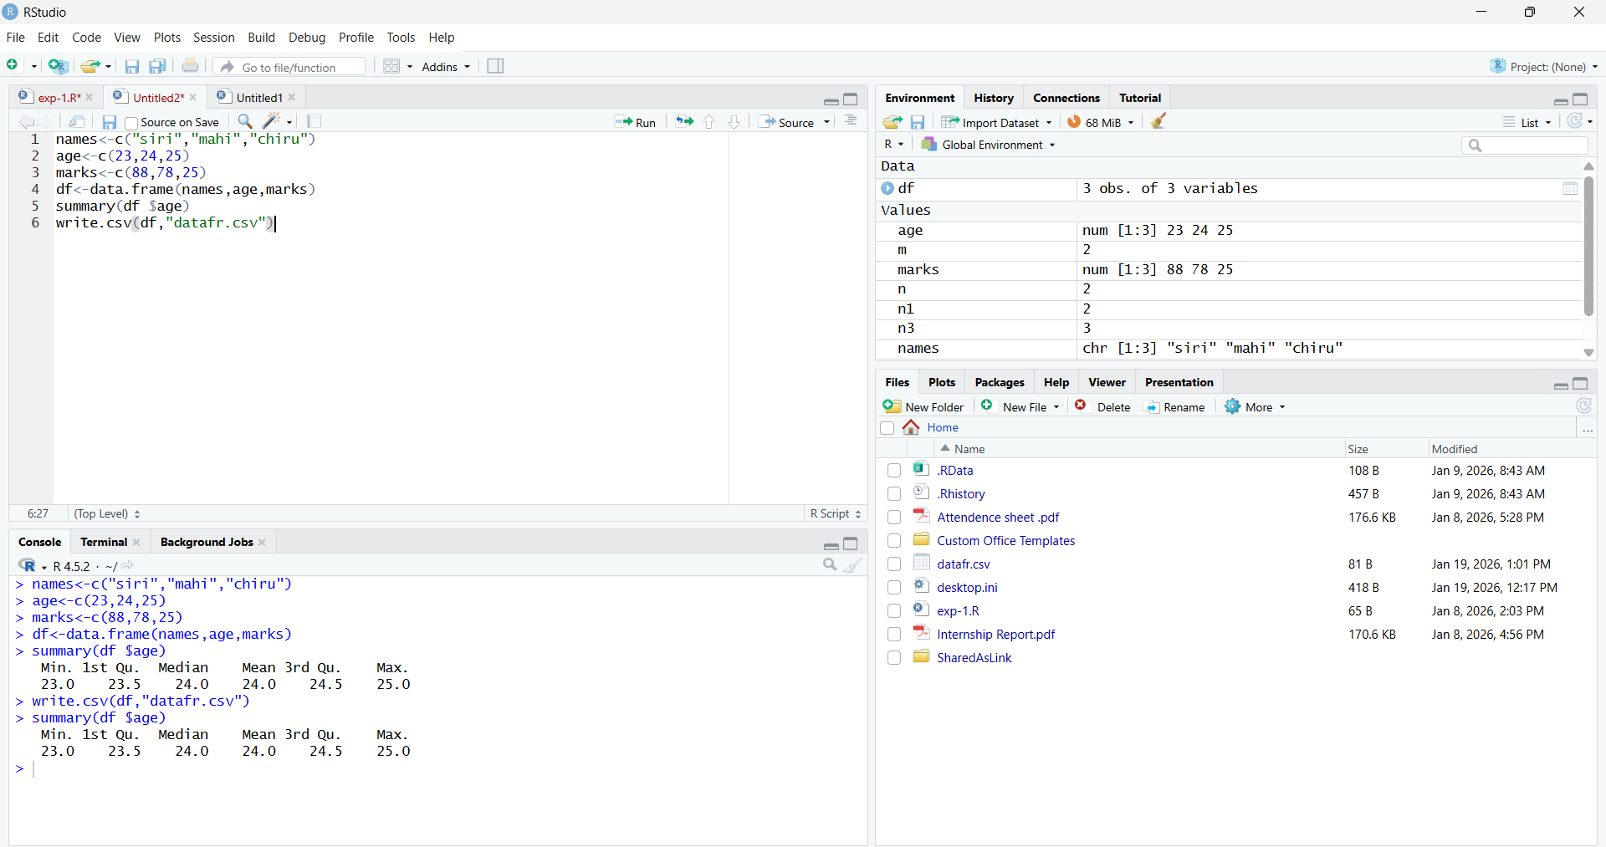
RESULT:
Thus, the central tendency and measure of dispersion is executed successfully.

EXPERIMENT-8 GREATER AMONG THREE NUMBERS:
AIM:
To write the program for the greatest among three numbers.
PROGRAM:
x <- as.numeric(readline(prompt = "Enter the first number: "))
y <- as.numeric(readline(prompt = "Enter the second number: "))
z <- as.numeric(readline(prompt = "Enter the third number: "))
numbers <- c(x, y, z)
cat("Greatest number is:", max(numbers), "\n")
OUTPUT:
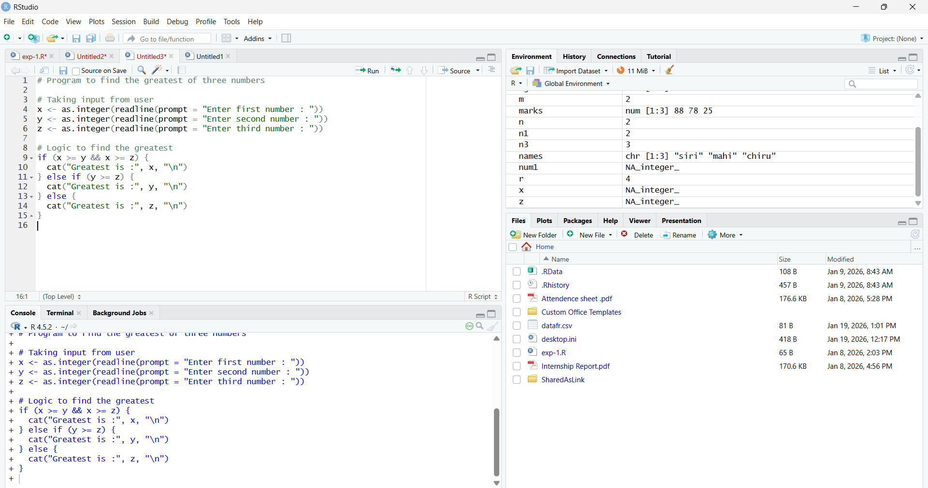
RESULT:
Thus, the greatest among the three numbers was executed successfully.

EXPERIMENT-9 IQR:
AIM:
To write the program for central tendency and data dispersion measures using R tool.
PROGRAM:
names <- c("siri", "mahi", "chiru")
age <- c(23, 24, 25)
marks <- c(88, 78, 25)
df <- data.frame(names, age, marks)
IQR(df$age)
write.csv(df, "datafr.csv", row.names = FALSE)
OUTPUT:
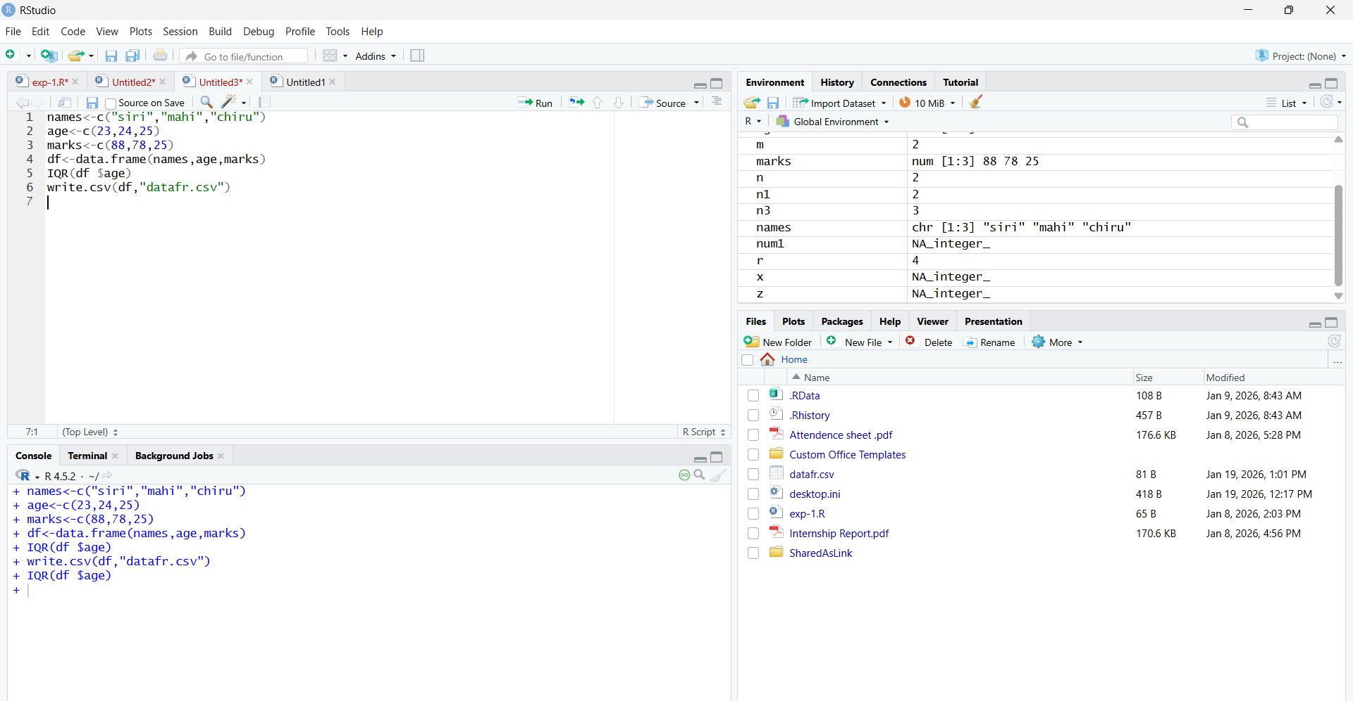
RESULT:
Thus, the program for central tendency and data dispersion measures was executed successfully.

EXPERIMENT-10 QUANTILE:
AIM:
To write the program for central tendency and data dispersion measures.
PROGRAM:
names <- c("siri", "mahi", "chiru")
age <- c(23, 24, 25)
marks <- c(88, 78, 25)
df <- data.frame(names, age, marks)
quantile(df$age)
write.csv(df, "datafr.csv", row.names = FALSE)
OUTPUT:
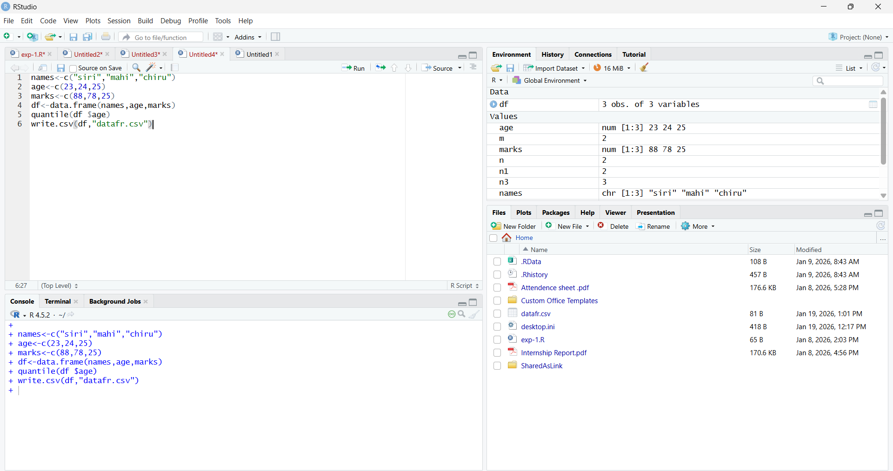
RESULT:
Thus, the program for central tendency and data dispersion measures was executed successfully

EXPERIMENT-11 MID RANGE:
AIM:
To write the program for central tendency and data dispersion measures.
PROGRAM:
names <- c("siri", "mahi", "chiru")
age <- c(23, 24, 25)
marks <- c(88, 78, 25)
df <- data.frame(names, age, marks)
mid_range <- (min(df$age) + max(df$age)) / 2
print(mid_range)
write.csv(df, "datafr.csv", row.names = FALSE)
OUTPUT:
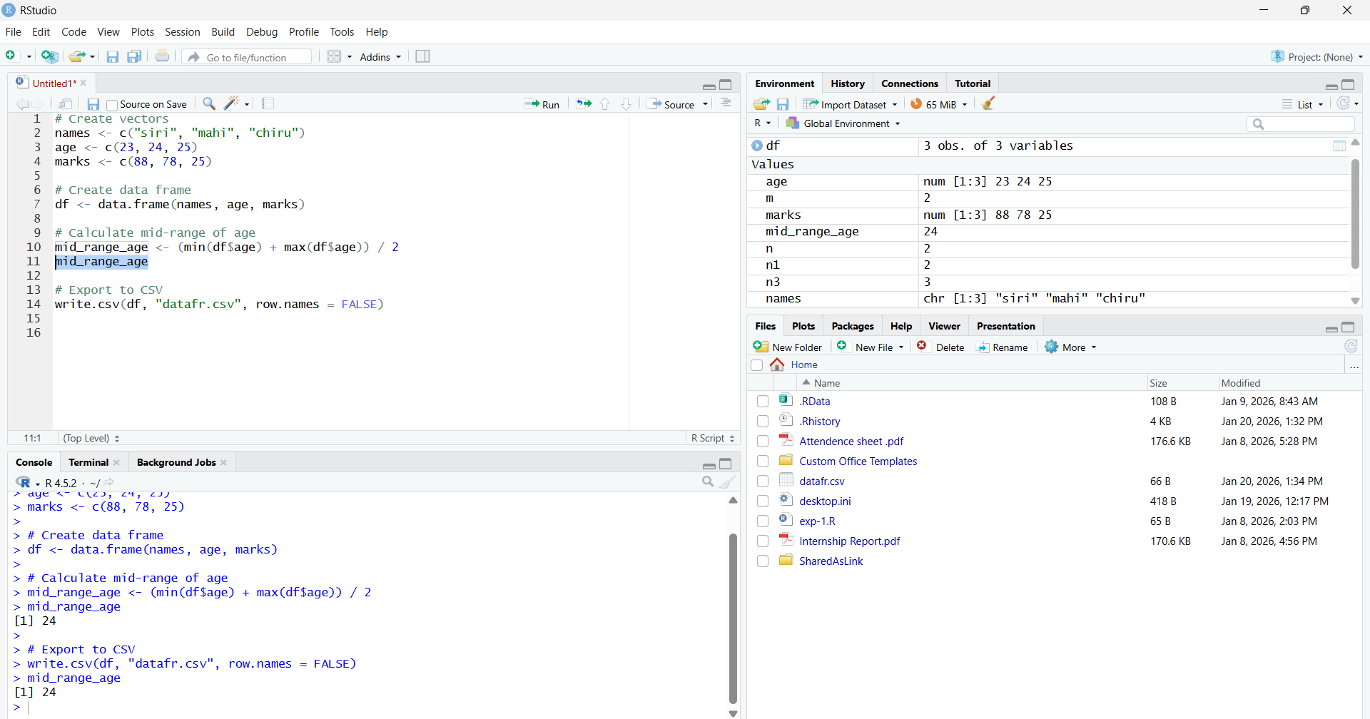
RESULT:
Thus, the program for central tendency and data dispersion measures was executed successfully

EXPERIMENT-12 Z-SCOORE NORMALIZATION:
AIM:
To write the program for Z-score normalization using R-tool.
PROGRAM:
# Install once if needed: install.packages("readxl")
library(readxl)
diabetest1 <- read_excel("NARA.xlsx") # Keep the file in the working directory
A <- as.numeric(diabetest1$Age)
Mean <- mean(A, na.rm = TRUE)
Std <- sd(A, na.rm = TRUE)
Zscore <- (A - Mean) / Std
print(Zscore)
OUTPUT:
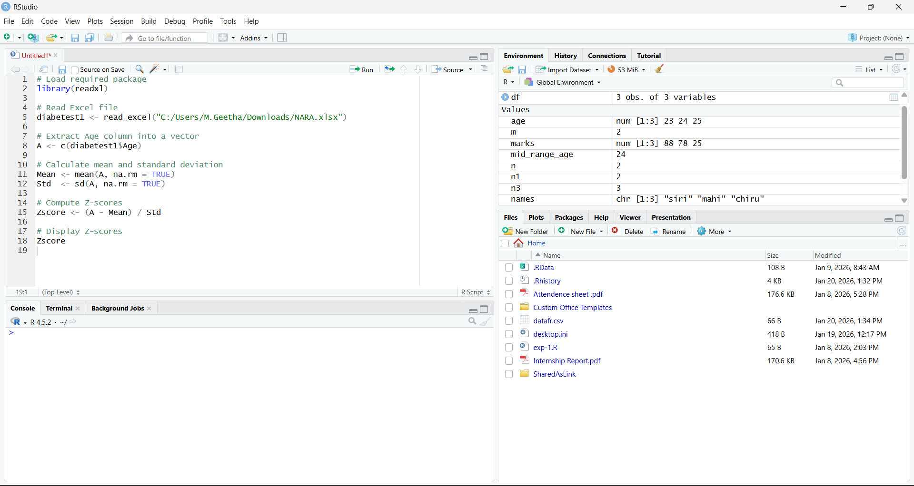

RESULT:
Thus, the Z-score normalization using R tool was executed successfully.

EXPERIMENT-13 MIN,MAX,MEAN,MINMAX:
AIM:

To write the program for the minimum,maximum,mean and minmax using r-TOOL

PROGRAM:
# Install once if needed: install.packages("readxl")
library(readxl)
diabetest1 <- read_excel("NARA.xlsx") # Keep the file in the working directory
A <- as.numeric(diabetest1$Age)
Mean <- mean(A, na.rm = TRUE)
Minimum <- min(A, na.rm = TRUE)
Maximum <- max(A, na.rm = TRUE)
MinMax <- (A - Minimum) / (Maximum - Minimum)
cat("Mean:", Mean, "\n")
cat("Minimum:", Minimum, "\n")
cat("Maximum:", Maximum, "\n")
print(MinMax)
OUTPUT:
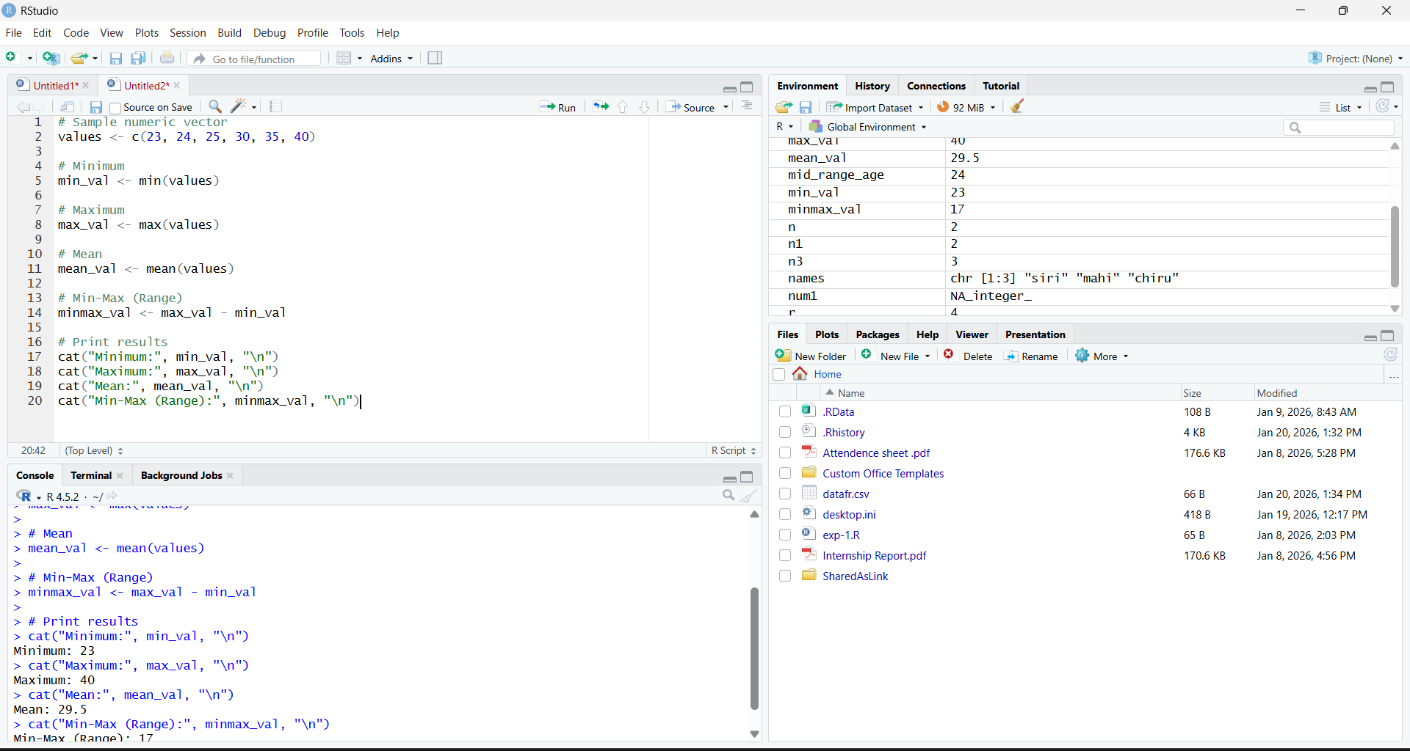
RESULT:
Thus, the program for min,max,minmax,mean was executed successfully.

EXPERIMENT-14 BAR PLOT AND HORIZONTAL BAR:
AIM:
To draw the bar plot and horizontal bar using R-tool.
PROGRAM:
marks <- c(55, 67, 89, 80, 90)
barplot(marks, names.arg = paste0("Student ", 1:5),
main = "Marks of Students", ylab = "Marks",
col = "lightblue")
barplot(marks, names.arg = paste0("Student ", 1:5),
main = "Marks of Students (Horizontal)", xlab = "Marks",
horiz = TRUE, col = "lightgreen")
OUTPUT:

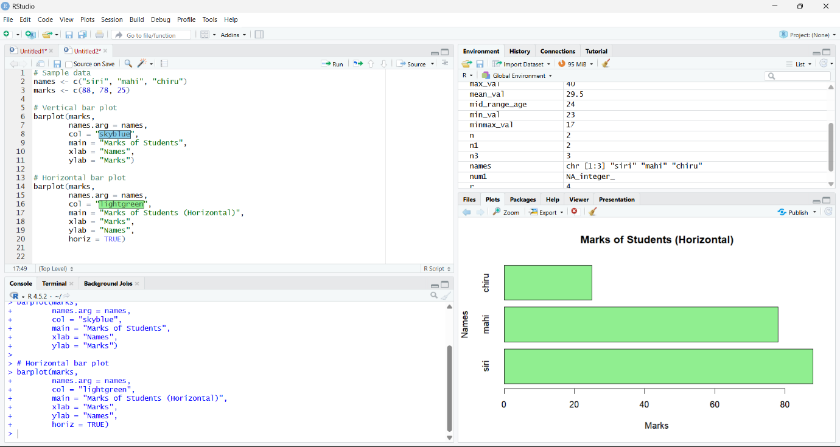
RESULT:
Thus, the bar and horizontal bar plot was executed successfully.

EXPERIMENT-15 BOX PLOT:
AIM:
To draw the box plot using R-tool.
PROGRAM:
names <- c("siri", "chiru", "loki")
age <- c(23, 24, 25)
marks <- c(88, 78, 25)
df <- data.frame(names, age, marks)
boxplot(df$age, main = "Box Plot of Age", ylab = "Age")
OUTPUT:
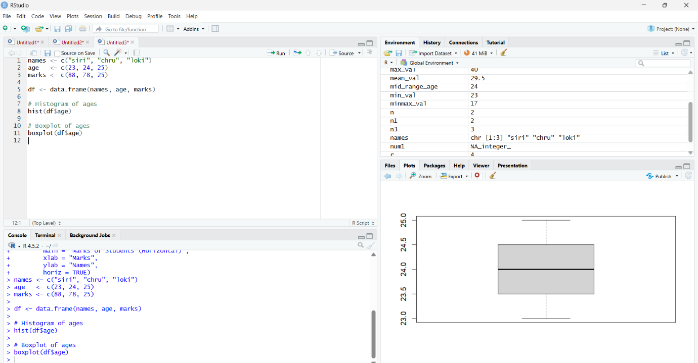

RESULT:
Thus, the box plot was executed successfully.

EXPERIMENT-16 HISTOGRAM:
AIM:
To draw the histogram plot using R-tooll.
PROGRAM:
marks <- c(55, 67, 89, 80, 90)
hist(marks, main = "Histogram of Marks", xlab = "Marks",
ylab = "Frequency", col = "lightblue", border = "black")
OUTPUT:
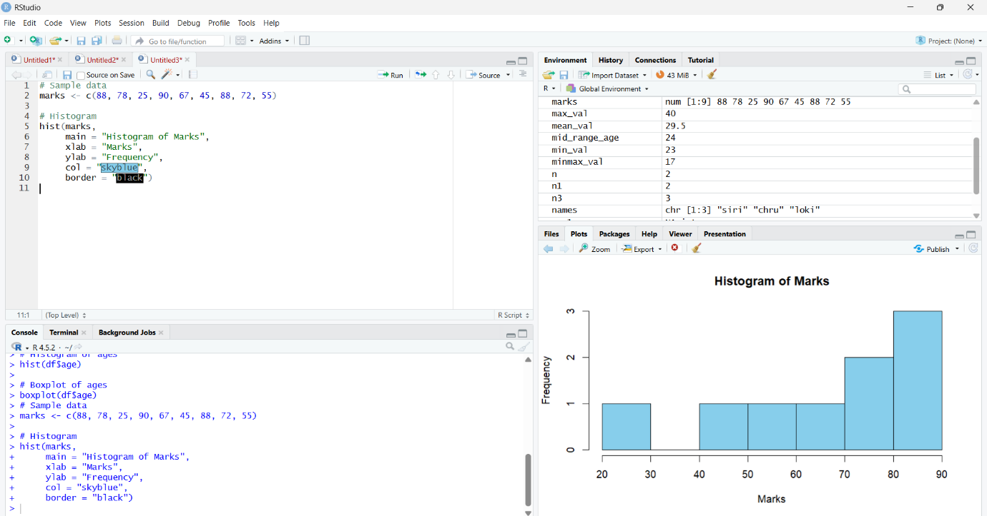

RESULT:
Thus, the histogram plot was executed successfully.

EXPERIMENT-17 CORRELATION ANALYSIS:
AIM:
To write the program for correlation analysis using R-tool.
PROGRAM:
age <- c(23, 24, 25)
marks <- c(88, 78, 25)
correlation <- cor(age, marks, use = "complete.obs", method = "pearson")
print(correlation)
OUTPUT:
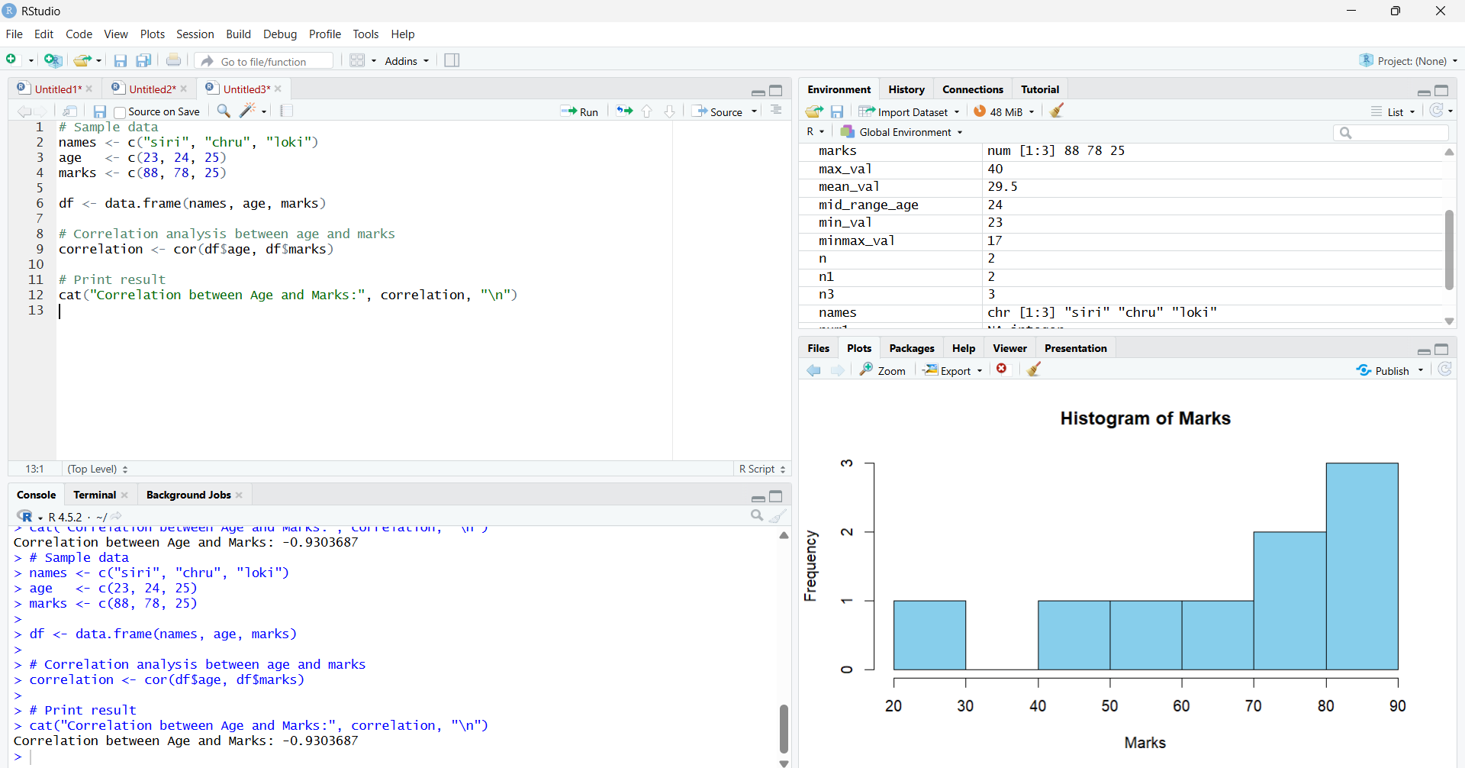
RESULT:
Thus, the correlation analysis was executed successfully.

EXPERIMENT-18 SCATTER PLOT:
AIM:
To draw the scatter plot using R-tool
PROGRAM:
age <- c(23, 24, 25)
marks <- c(88, 78, 25)
plot(age, marks, main = "Scatter Plot of Age vs Marks",
xlab = "Age", ylab = "Marks", pch = 19, col = "blue")
OUTPUT:
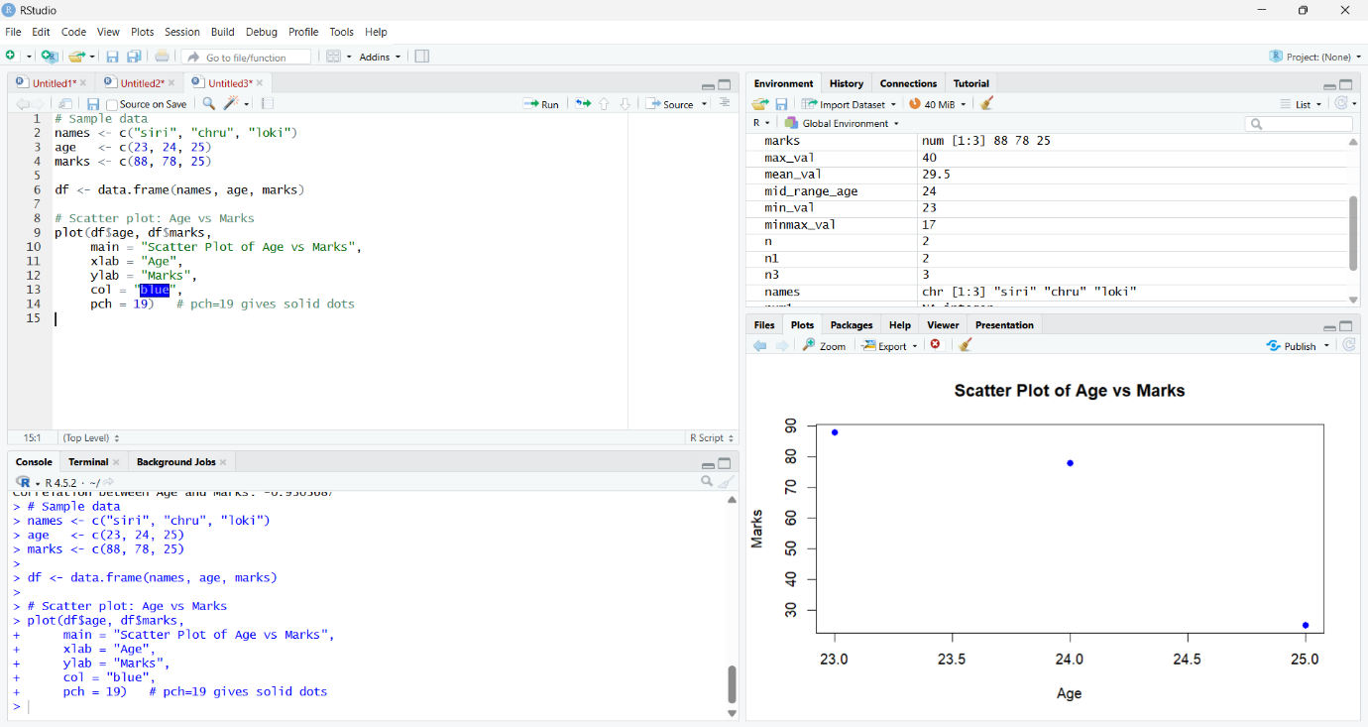

RESULT:
Thus, the scatter plot was executed successfully.

EXPERIMENT-19 LINEAR REGRESSION:
AIM:
To write thr program for the linear regression using R-tool.
PROGRAM:
age <- c(23, 24, 25)
marks <- c(88, 78, 25)
students <- data.frame(age, marks)
model <- lm(marks ~ age, data = students)
plot(students$age, students$marks, main = "Linear Regression: Marks vs Age",
xlab = "Age", ylab = "Marks", pch = 19, col = "blue")
abline(model, col = "red", lwd = 2)
summary(model)
OUTPUT:
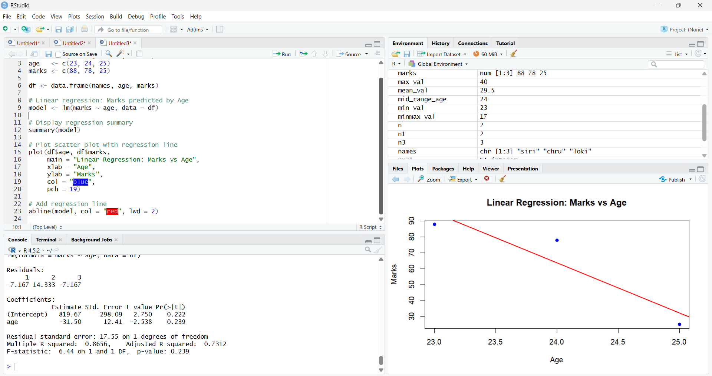
RESULT:
Thus, the linear regression program was executed successfully.

EXPERIMENT-20 MULTIPLE REGRESSION:
AIM:
To write the program for the multiple regression.
PROGRAM:
students <- data.frame(
Age = c(20, 21, 22, 23, 24, 25, 26, 27),
BloodPressure = c(110, 115, 118, 120, 125, 128, 130, 135),
Glucose = c(90, 95, 100, 105, 110, 115, 120, 125)
)
model <- lm(Glucose ~ Age + BloodPressure, data = students)
summary(model)
# Optional: predicted glucose values
predict(model)
OUTPUT:
